Cau 1

import pytest

a = [2,5,7,8]

def test_equal_1(A):

T = True

F = False

prime = True

C = 0

B = len(A)

for i in range(B):

if (A[i] == 2 ):

C = C + 1

elif (A[i] < 2):

prime = False

elif (A[i] % 2 == 0):

prime = False

else :

for n in range(2,A[i]):

if (A[i] % n == 0 ):

prime = False

else :

C = C + 1

#assert C == 0 , "khong co so nguyen to nao"

#assert C == 1 , "mot mang co mot so nguyen to"

#assert C == 2 , "mot mang co nhieu hon mot so nguyen to"

if (C >= 2):

return T

if (C < 2 ):

return F

print(test_equal_1(a))

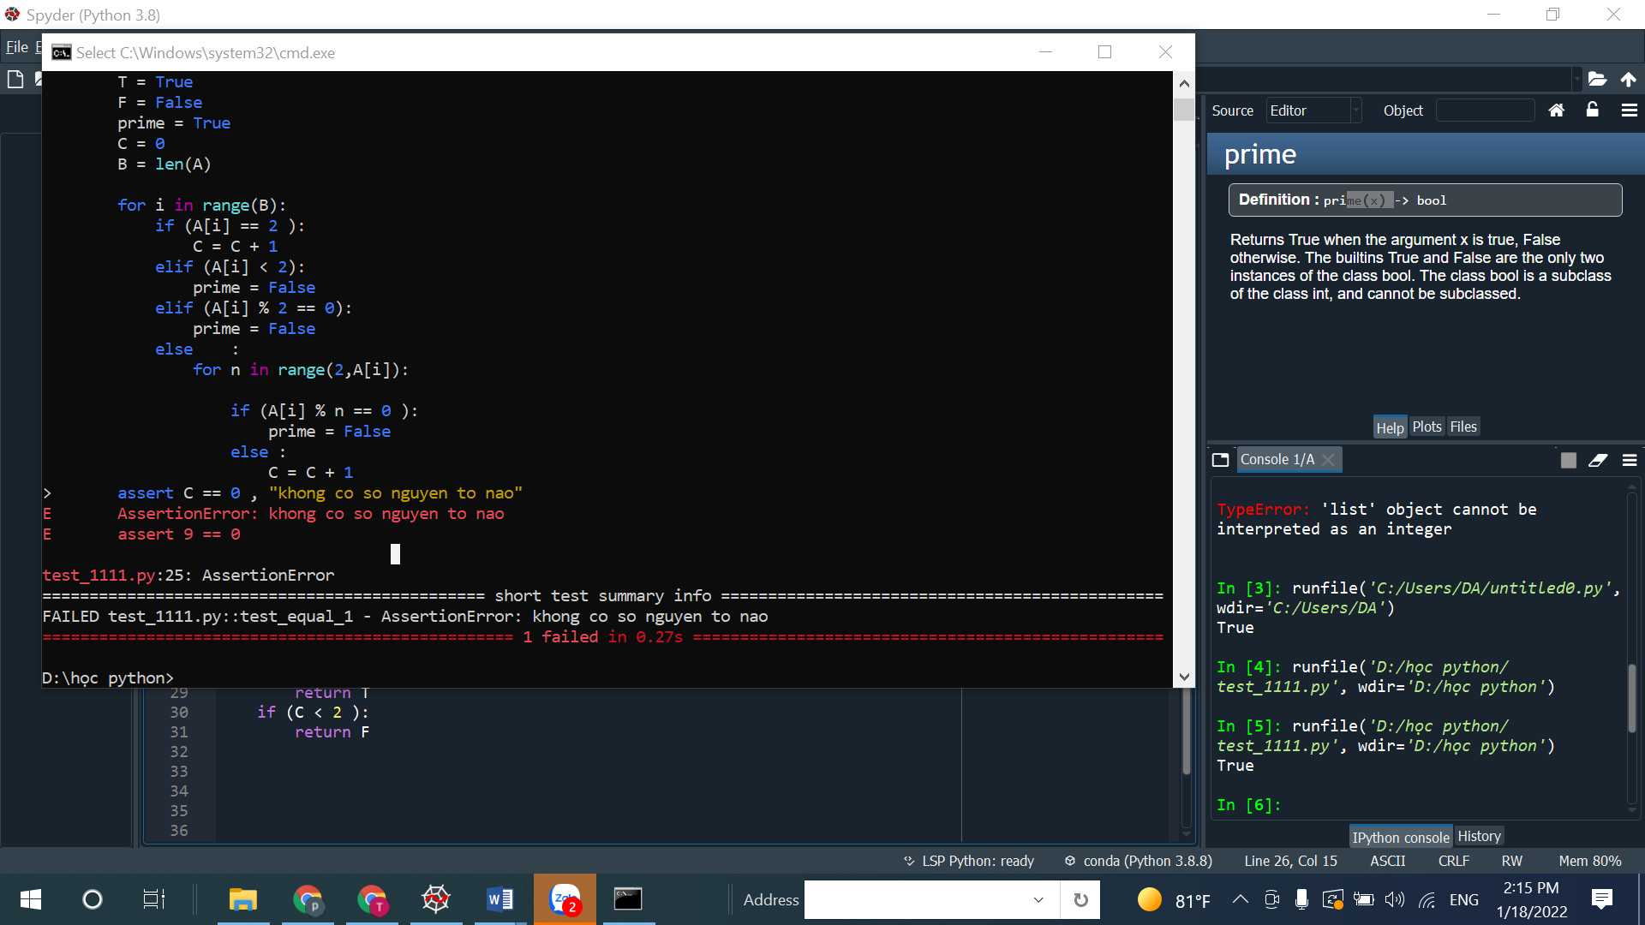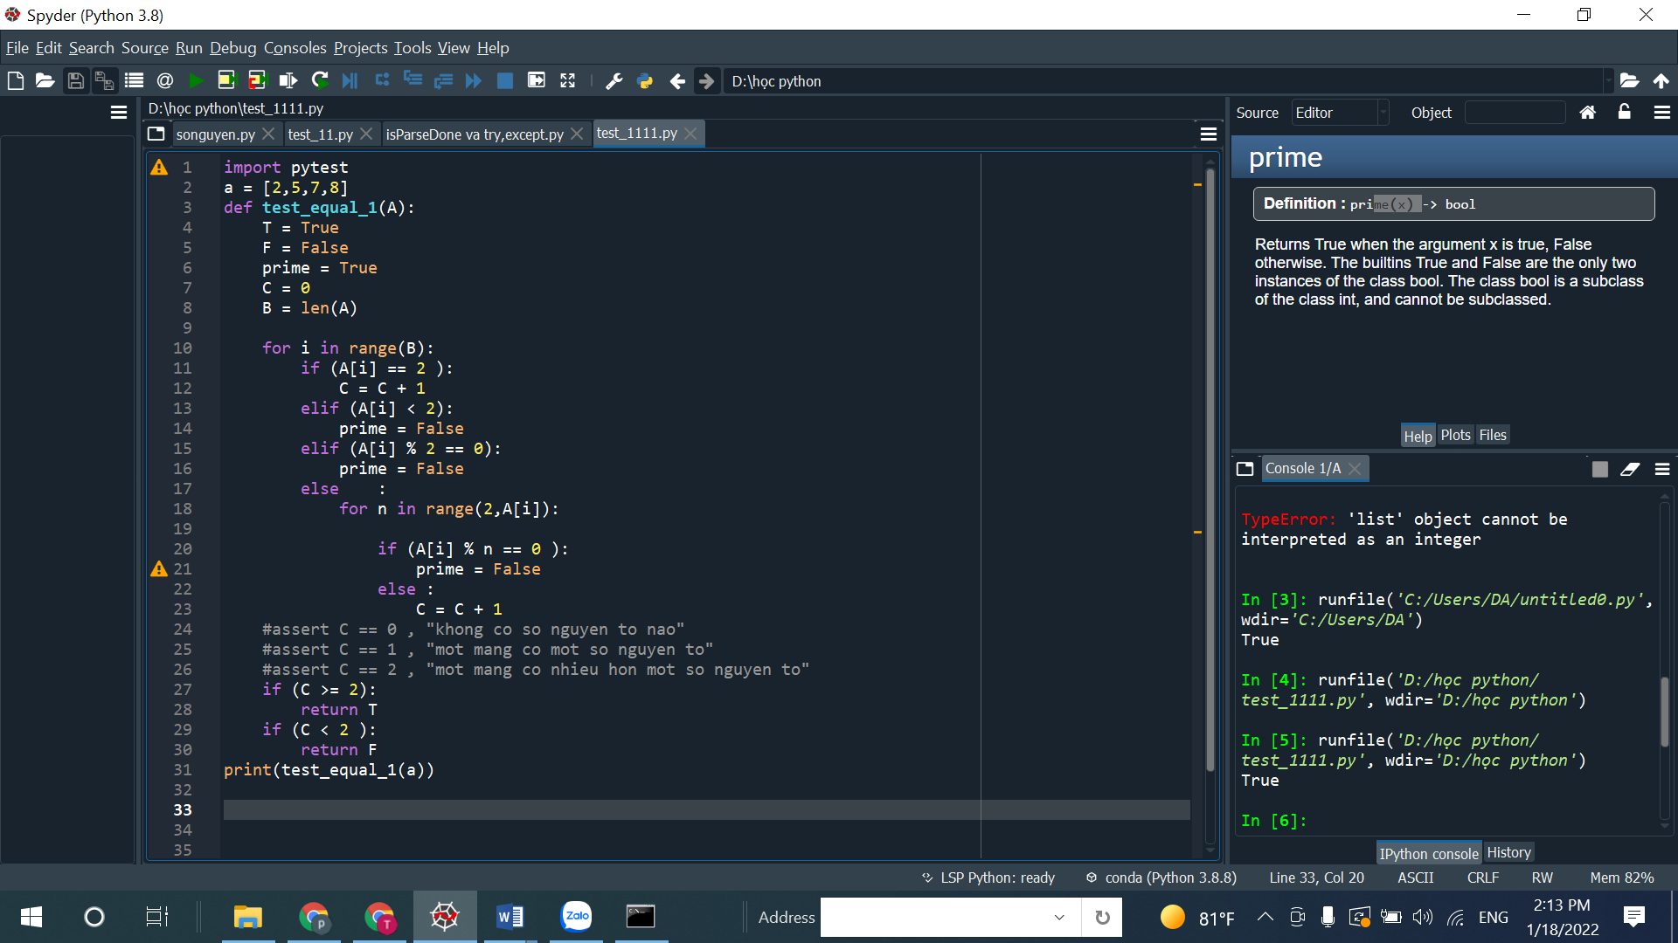

Cau 2

class Real_Number :

def __int__(self,real_number):

self.real_number = real_number

def real_number(self):

return self.real_number

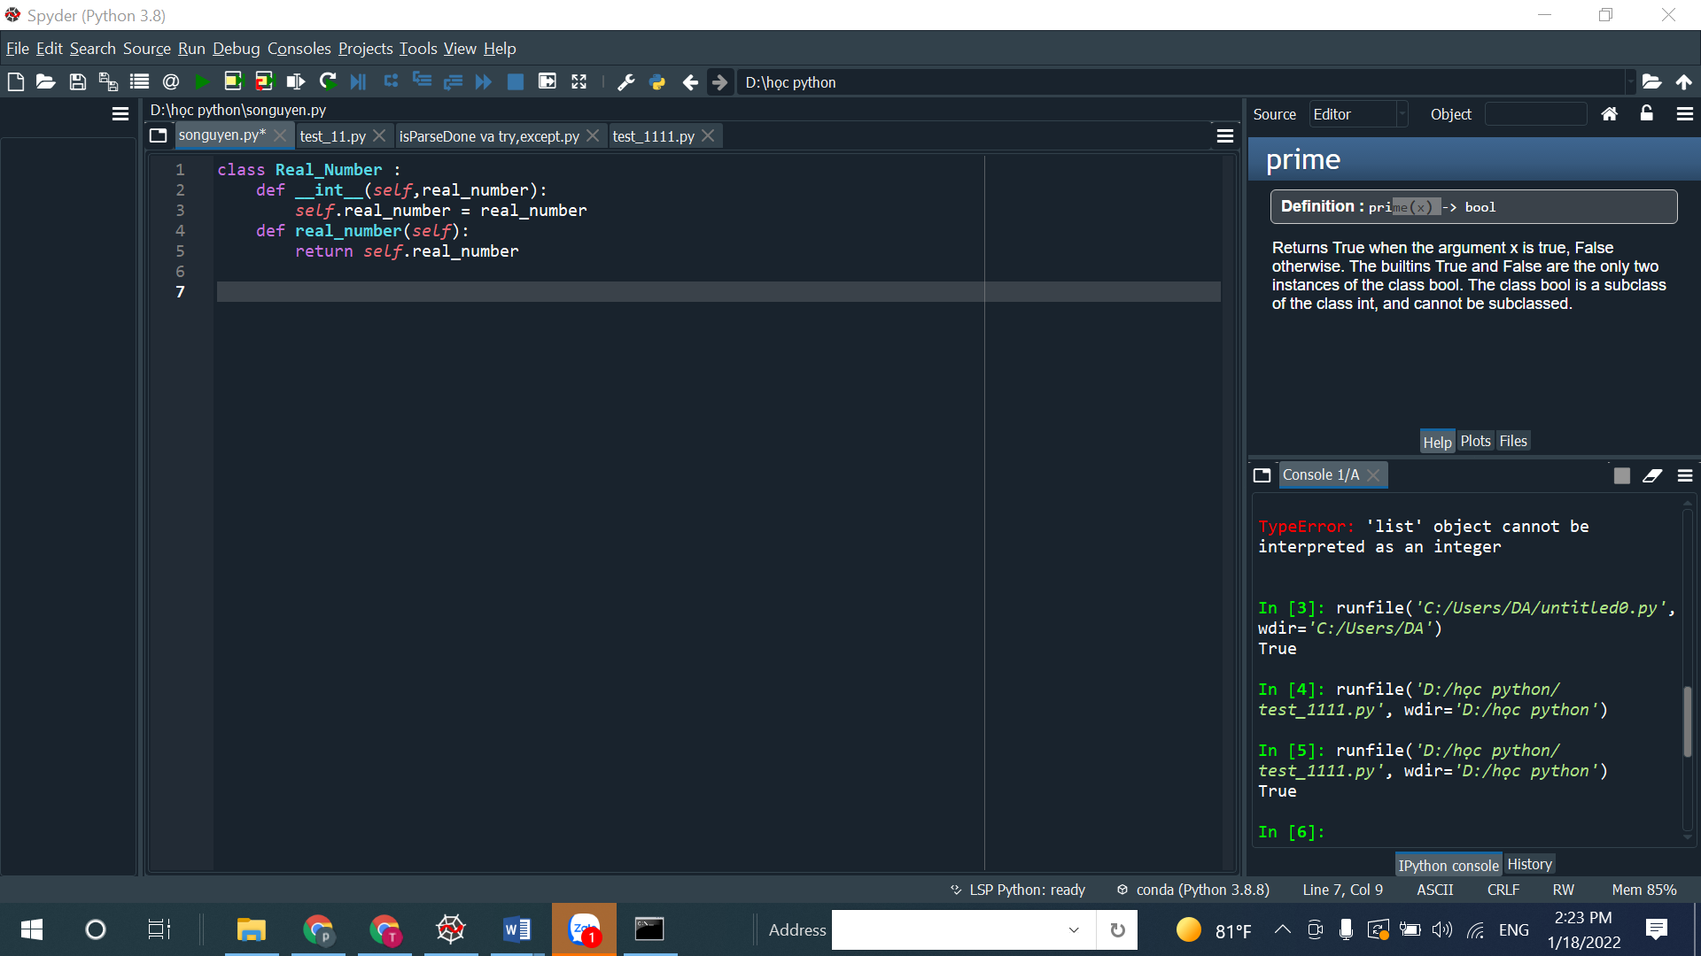

Cau 3

SELECT a.cust_name AS "Customer Name", a.city, b.name AS "Salesman", b.commission FROM customer a INNER JOIN salesman b

ON a.salesman_id=b.salesman_id

WHERE b.commission>.12;